Student Resource 11.5
Reading: An Overview of Property Insurance
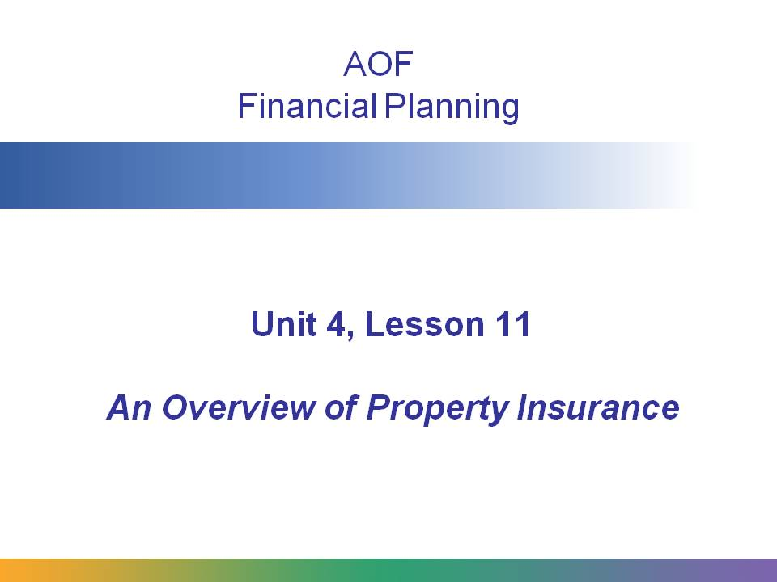
This overview will cover the following topics:

- How property insurance covers some of our most valuable assets
- What’s usually covered: fire, theft, personal liability, some weather damage
- What’s usually not covered: earthquake, flood, acts of war and terrorism
- The role of the government/FEMA in the case of massive disasters
- Is property insurance for renters? Renters insurance, and why non-homeowners may need coverage
- Details on an insurance plan: the difference between open perils and named perils; the concept of a deductible
- Factors that determine premium pricing (geographical location, proximity to fire stations and hydrants, roof type, etc.)
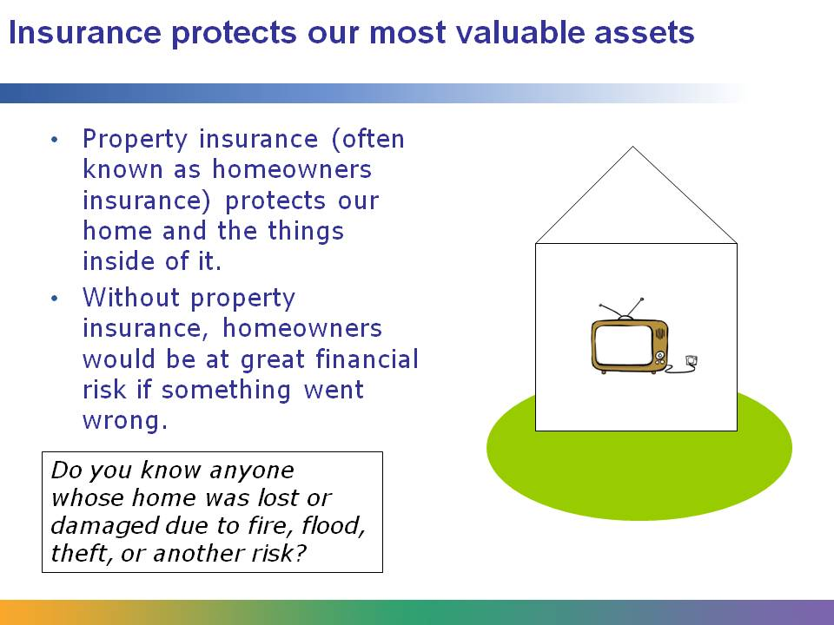
For many people, their home is their most valuable asset. Property insurance not only protects the house we live in, but also the things inside it, such as computers, electronics, jewelry, clothing, and other valuables.
Without property insurance, we would be at great financial risk of losing all of these important assets if something bad happened.
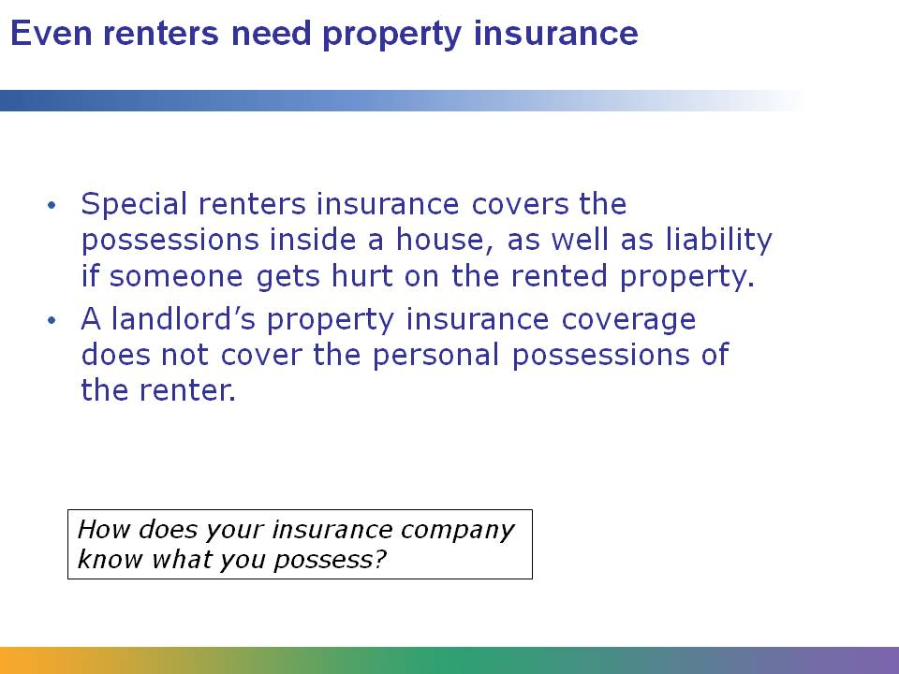
Renters insurance has much lower premiums than standard property insurance, as it does not protect the home itself, but only its contents. Usually the landlord will have property insurance.
Renters insurance provides important protection to loss of your possessions due to fire, weather damage, or theft. It is also provides you with important liability protection.
If you get renters insurance, you will have to inventory all of the important possessions in your house so that they are covered in case of loss. With today’s technology advances, often the easiest way to document possessions is to create digital video images with a camera, camcorder, or even a cell phone, and then to store the images in a safe place away from the residence.

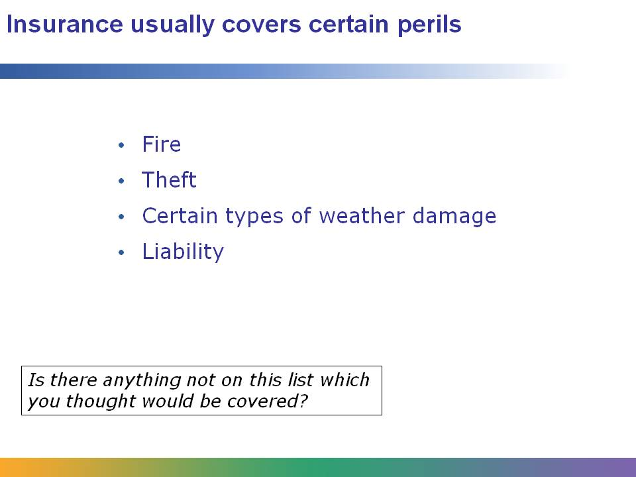
Most types of property insurance protect our home and its belongings in case of the following events:
- Fire
- Theft
- Certain types of weather damage (but there are some types of weather damage that are not automatically covered)
- Liability
Liability is an important type of coverage. It means that if a visitor hurts herself on your property, your insurance will take care of the expenses. And if she sues you and wins, the insurance company will pay what the court decides you owe her, up to the limits of your policy.
It is important to know that most insurance pays only for the cost to replace the home. So even though the market value of your home might be $250,000, if it only costs $70,000 to rebuild it on the property, that is the amount likely to be covered.
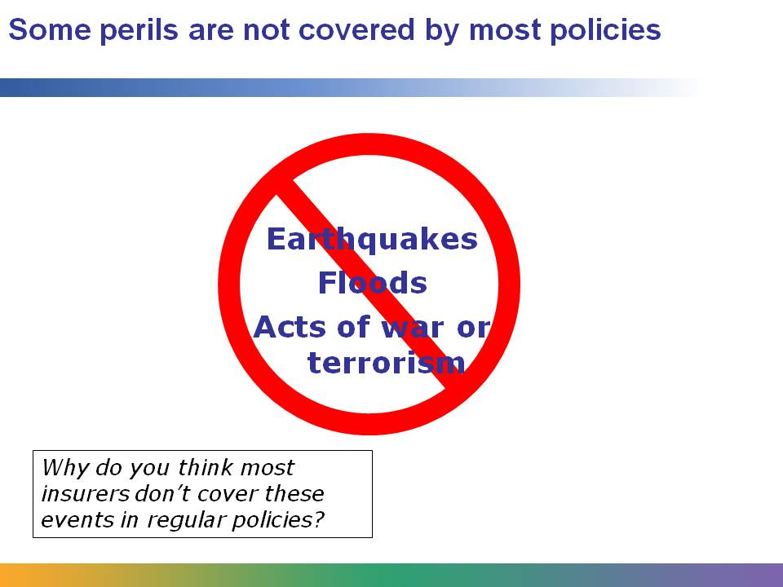
Most insurance companies don’t cover the following events in their standard insurance policies:
- Earthquakes
- Floods
- Acts of war or terrorism
Some insurers and some government agencies offer insurance policies that cover these events, especially earthquake and flood insurance⎯but they are very expensive!
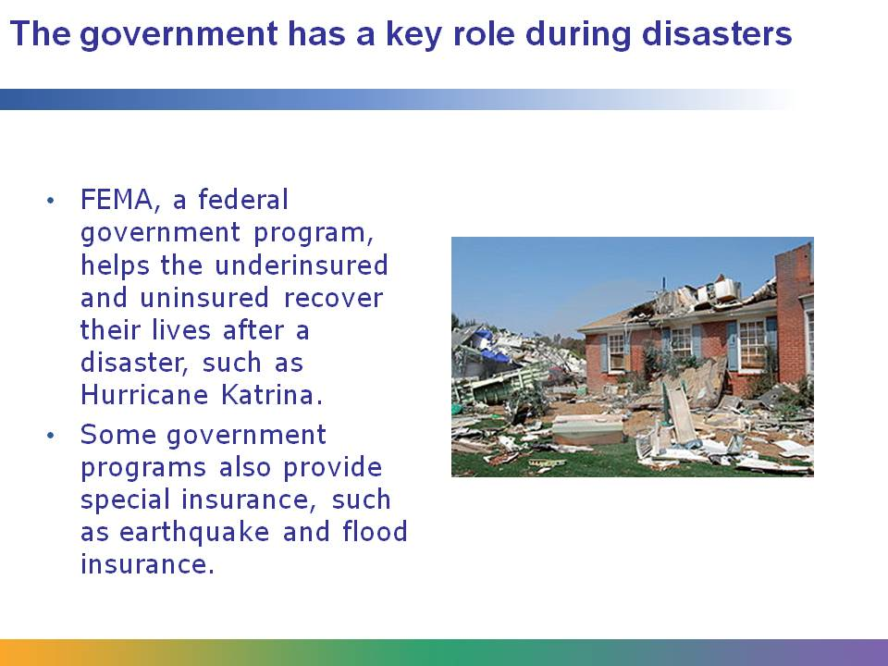
One of the key principles of insurance is that not everyone who has insurance experiences a loss at the same time, allowing insurers to spread the risk among all of their policyholders. Because a major disaster (such as earthquake or flood) does not allow the spread of risk—in a disaster everyone experiences a loss simultaneously—the private insurance industry does not, for the most part, provide coverage for such events.
Nevertheless, many people need certain types of insurance that private insurers can’t provide, to protect them from disasters such as floods in New Orleans or earthquakes in California. Often the government fills the void by providing insurance through federal or state insurance programs. Still, not everyone will have insurance to cover a disaster. When a concentrated disaster occurs, the government helps the underinsured and uninsured recover by providing assistance after the event occurs.

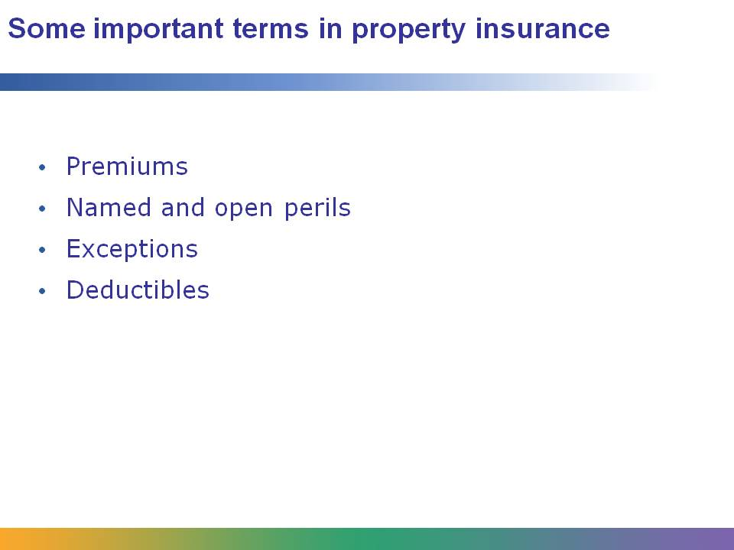
There are some key terms to understand in property insurance:
Premiums are the regular payments (usually monthly) that the insured person must make to the insurance company.
Insurance policies are a type of legal contract; they must be very clear and explicit in what they cover. One type of policy coverage is named perils. This means the policy explicitly covers those perils (such as fire, theft, lightning) that it names in the policy. Any peril not specifically listed is often not covered.
When a policy has open perils, it means that it provides certain types of coverage regardless of the cause of the damage.
Exceptions are types of perils that a policy specifically does not cover.
Deductibles are dollar amounts that the insured person must pay first before the insurance company will cover an event. Usually, the higher the deductible, the lower the insurance premiums. If you are confident that your risk of loss is low and you have sufficient emergency savings set aside, it can be wise to select a much higher deductible to save money.

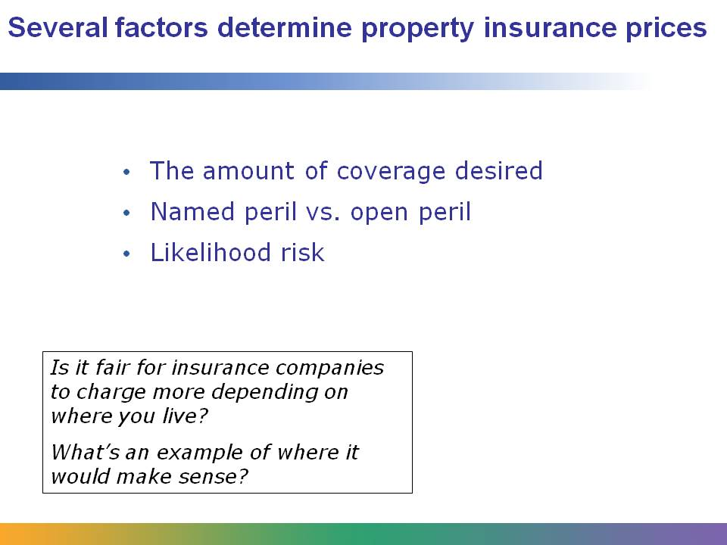
Homeowners have many choices to make when determining the type of insurance to purchase. The price of insurance depends on these choices, on the value of that being insured, and on the likelihood of risk to the insured property.
Homeowners can select policies that:
- Have a higher or lower deductible
- Are named peril or open peril
- Cover special types of perils, such as earthquake and flood
- Cover a higher or lower percentage of the value of the house
Insurance companies charge more for homes that have a higher risk, such as those that:
- Are in areas with higher risk of fires
- Are a long distance from the nearest fire hydrant
- Have roofs made from easily combustible material
- Are located in areas with high rates of theft or vandalism

